CONFERENCE, 6-8 NOVEMBER 2008
‘PHYSIOGNOMY from DELLA PORTA to LAVATER’
Conference locations: travel instructions

Conference delegates will be accommodated at the Tavistock Hotel (Tavistock Square, Bloomsbury, WC1H 9EU). Travel directions below are given from this location to National Gallery, to the two conference locations (QMUL, that is, Queen Mary University of London, Mile End Road, London E1 4NS – Thursday; the British Academy, 10 Carlton House Terrace, London SW1 5AH – Friday and Saturday), and to the restaurant where the conference dinner will be held on Friday (Sofra 36 Tavistock Street, London, WC2E 7PB (close to Covent Garden)). The dinner on Thursday evening will take place at the gastropub, L’Oasis, on the Mile End Road a short walking distance from the conference location.
- Thursday 6 November. i. ‘The Renaissance Face’ Exhibition
Delegates will visit the ‘The Renaissance Face’ exhibition in the late morning and afternoon of Thursday, 6 November, before the conference begins. The exhibition is at the National Gallery, Trafalgar Square. Separate details about these visits will be provided. Trafalgar Square is about 25-30 minutes walk from the hotel. Public transport options and walking directions are shown below, under the section on the British Academy (which is very close to Trafalgar Square).
- Thursday 6 November. ii. Conference at QMUL
Travel to QMUL from the National Gallery is very straightforward. Enter Charing Cross tube station from the stairway on Trafalgar Square. Take the Northern Line north (to Edgware or High Barnet). Change at Tottenham Court Road on to the Central Line, travelling east. Alight at Mile End Tube. Allow 30-35 minutes.
Travel from the Tavistock Hotel is slightly more complicated. Take Bus 91 from Tavistock Square toward Trafalgar Square. Stop at Holborn. Take the Central Line (Tube –Red) from Holborn station to Mile End. Allow 40-45 minutes journey time.

Start of journey:
Bus Stop: Tavistock Square
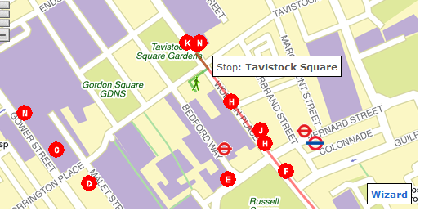
Tavistock Hotel
Interchange:
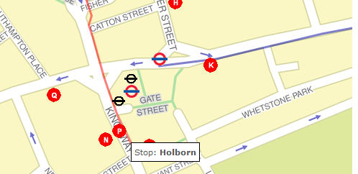
Tube: Holborn
End of journey:
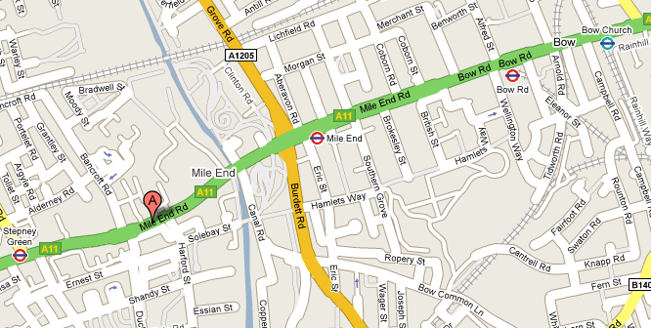
Queen Mary University of London

- Friday & Saturday, 7-8 November. Conference at the British Academy
Tavistock Hotel (Tavistock Square, Bloomsbury, WC1H 9EU) to The British Academy (10 Carlton House Terrace, London SW1Y 5AH) (Friday and Saturday):
The British Museum
Walking time is around 30-35 minutes.
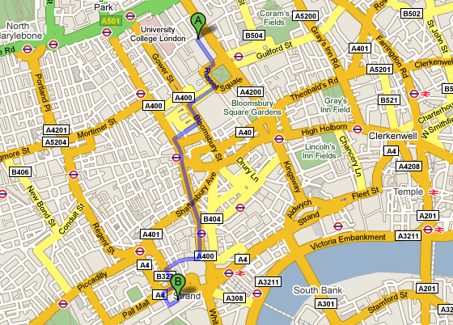
Tottenham Court Road
Covent Garden
Trafalgar Square and National Gallery
Piccadilly Circus

Alternatively take Bus 91 from Tavistock Square toward Trafalgar Square. Stop at Trafalgar Square. Walk to the British Academy. Allow 40-45 minutes journey time.

Start of journey:
Bus Stop: Tavistock Square
Tavistock Hotel

End of journey:
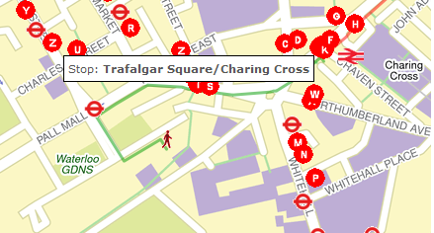
Trafalgar Square
The British Academy

- Friday evening conference dinner: Sofra, 36 Tavistock Street, London, WC2E 7PB (close to Covent Garden)
On the Friday evening, the conference dinner will be in Sofra restaurant close to Covent Garden. The table is booked from 8pm.
Tavistock Hotel to Sofra
Walking time is around 25 minutes
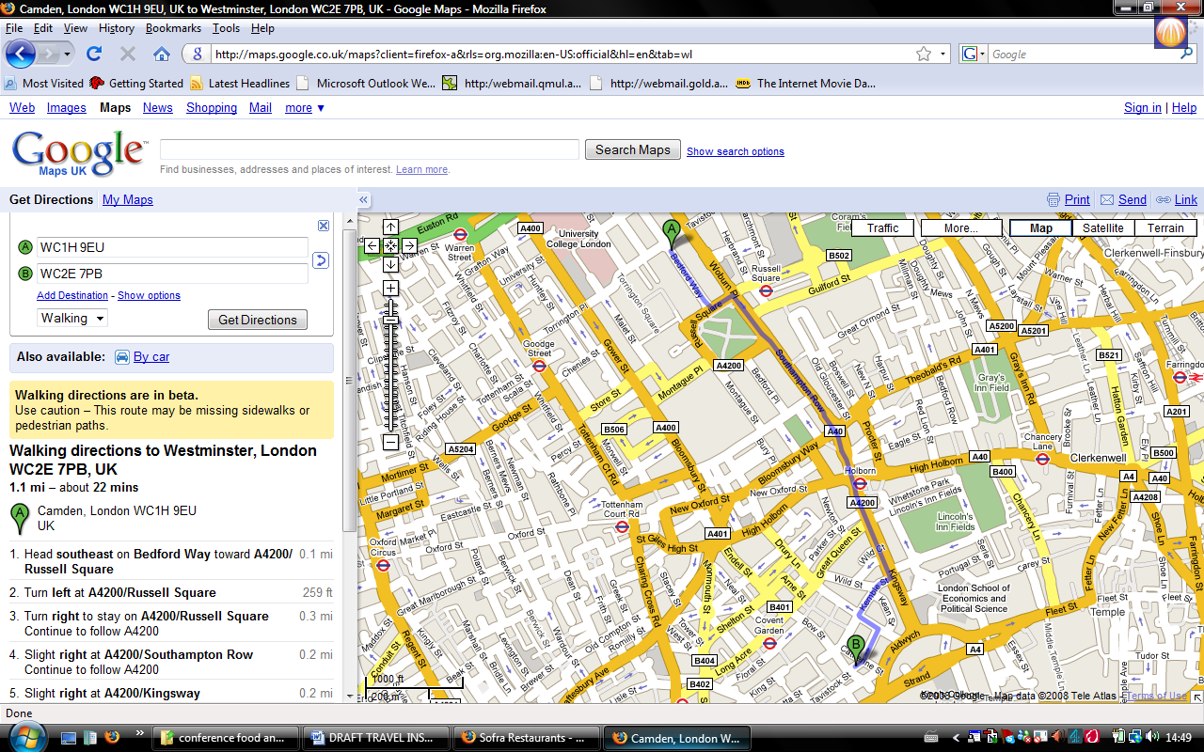

Alternatively, take Bus 91 towards Trafalgar Square, Bus 68 towards West Norwood, Bus 168 towards Dunton Road / Old Kent Road, or Bus 59 towards Streatham Hill/Telford Avenue. Stop at Aldwich, and walk to Tavistock Street. Allow 25mins for the journey.

Start of journey:
Bus Stop: Tavistock Square
Tavistock Hotel

End of journey:
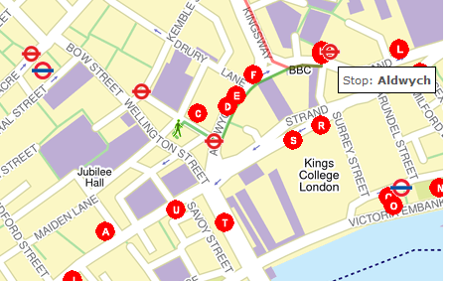
Sofra, Tavistock Street

Covent Garden

